EarthTeam Star (ETS) Token

Tracking and Rewarding Collaboration, Action and Impact in Planetary Health

ETS is a blockchain token that tracks and rewards actions and impacts that restore and maintain planetary health. These actions and impacts are submitted, measured and verified using the EarthTeam App. Token and App launch date: September 1, 2026. View listing on Solana here.

ETS can be earned and used by anyone: civil society, students, governments and the public.

ETS Is the operational “currency” of EarthTeam (www.earth-team.org), a global alliance of frontline organizations and individuals working to protect our planet and people from biodiversity loss and pandemics. Members are united by a vision of a world reset –with temperatures cooling, species and habitats recovering, and communities thriving and safe from outbreaks.
To achieve this vision, EarthTeam incentivizes collaboration and impact through EarthTeam Stars (ETS). Members use ETS to track and reward their actions and impact, making the token dual purpose; a Monitoring and Evaluation Tool, and a redeemable Reward Certificate. ETS is a Star on your calendar that includes data on how it was earned.
Earning: An EarthTeam “Roadmap” lists actions and solutions to be supported to realize our vision.

Tracking: Users add their profiles, actions and impacts to the EarthTeam Map for the world to see and support. Tokens are issued by the ETS community on three levels:

Level 1 (COPPER): Participation: Showing up to collaborate by telling us who you are, and what you’re doing. Level 2 (SILVER): Action: Concrete actions to protect wildlife, habitat, or to support regenerative agriculture. Level 3 (GOLD-PLATINUM): Verified recovery of species or habitats, lower risk of pandemic or global warming.

Each time participation, action and impact are recorded and verified, corresponding levels of ETS are released to a user’s wallet. A wallet is obtained by signing up to EarthTeam.

Traction: 20 NGOs onboarded.

Exchanging Tokens: EarthTeam’s global community has created its own market place in which tokens can be exchanged for tools, adventures, travel, fundraising support, paid holidays, and much more.

The value of ETS: A finite supply of 510 million ETS are minted, corresponding to the number of square kilometers covering earth. Tokens contain data on how they were earned, and can be (a) used for reports and funding proposals to demonstrate verified action and impact; and (b) bundled to earn biodiversity & carbon credits.

What ETS supports: a global alliance of frontline protectors and projects that safeguard and regenerate Earth. EarthTeam represents over 100+ organizations worldwide and continues to grow. Our mission has reached over 750 million people through conventional and social media. Join EarthTeam and earn: www.earth-team.org.

Earth team’s actions that are tracked and rewarded fall under the “Planetary Health” approach that includes:
- Wildlife Protection
- Habitat Protection
- Regenerative Agriculture

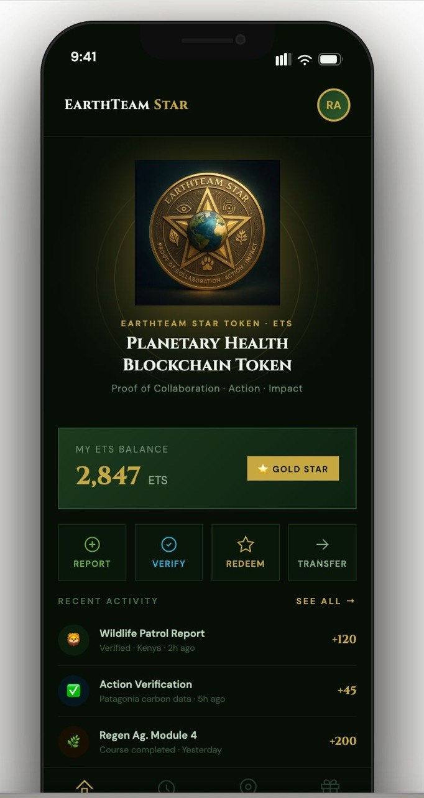

© Copyright ACET Ltd, US Tax ID: 83-337-1290 for EarthTeam. ACET (dba EarthTeam) is a company established by Freeland.

